**MIAMI-DADE COUNTY PUBLIC SCHOOLS**

**FEE-BASED COMMUNITY EDUCATION AND BEFORE AND AFTER SCHOOL PROGRAMS**



EFFECTIVE - 10-01-20

PAYMENT SCHEDULE AND RATES HAVE BEEN REVISED DUE TO

STAGE II – COVID 19



2020 - 2021   
before and after school care PROGRAM   
parent handbook

Providing Quality Programs Beyond School Hours



**SCHOOL BOARD MEMBERS**

Ms. Perla Tabares Hantman, Chair

Dr. Martin S. Karp, Vice-Chair

Dr. Dorothy Bendross-Mindingall

Ms. Susie V. Castillo

Dr. Lawrence S. Feldman

Dr. Steve Gallon III

Ms. Lubby Navarro

Dr. Marta Pérez

Ms. Mari Tere Rojas

**SUPERINTENDENT OF SCHOOLS**

#### Mr. Alberto M. Carvalho

**FEE-BASED COMMUNITY EDUCATION AND**

**BEFORE / AFTER SCHOOL CARE PARENT HANDBOOK:**

**PROGRAM GUIDELINES**

|  |  |  |  |  |
| --- | --- | --- | --- | --- |
| **2020 - 2021 ANNUAL SCHOOL YEAR PROGRAMS**  **(MONDAY, AUGUST 24, 2020 to WEDNESDAY, JUNE 09, 2021)** | | | | |
| **NAME OF PROGRAM** | **HOURS OF OPERATION** | | **WEEKLY RATE** | **FEE REDUCTIONS** |
| BEFORE SCHOOL CARE | 7:00 a.m. to 8:25 a.m. | | $20.00 / $30.00 BASE / STAGE II | No fee reduction |
| STORY HOUR | 1:50 p.m. to 3:00 p.m. | | $20.00 / $30.00 BASE / STAGE II | No fee reduction |
| AFTER SCHOOL CARE | 1:50 p.m. to 6:00 p.m. | | $40.00 / $60.00 BASE / STAGE II | Students that qualify for the Free  or Reduced Lunch student rate  will only pay:  $35.00 per week - BASE  **($1.00 off per day)**  $55.00 per week - STAGE II  **($1.00 off per day)** |
| **2021 SUMMER PROGRAMS**  **(RANGE OF OPERATIONS: MONDAY, JUNE 14, 2021 to FRIDAY, AUGUST 20, 2021)** | | | | |
| **NAME OF PROGRAM** | | **HOURS OF OPERATION** | **WEEKLY RATE** | **FEE REDUCTIONS** |
| AFTER SCHOOL CARE | | 1:50 p.m. to 6:00 p.m. | $40.00 / $60.00 BASE / STAGE II | Students that qualify for the Free  or Reduced Lunch student rate  will only pay:  $35.00 per week - BASE  **($1.00 off per day)**  $55.00 per week - STAGE II  **($1.00 off per day)** |
| HALF-DAY SUMMER CAMP PROGRAM | | 11:30 a.m. to 6:00 p.m. | $60.00 / $90.00 BASE / STAGE II | Students that qualify for the Free  or Reduced Lunch student rate  will only pay:  $55.00 per week - BASE  **($1.00 off per day)**  $85.00 per week - STAGE II  **($1.00 off per day)** |
| FULL-DAY SUMMER CAMP PROGRAM | | 7:00 a.m. to 6:00 p.m. | $100.00 / $150.00 BASE / STAGE II | Students that qualify for the Free  or Reduced Lunch student rate  will only pay:  $90.00 per week - BASE  **($2.00 off per day)**  $140.00 per week - STAGE II  **($2.00 off per day)** |

**FEE-BASED COMMUNITY EDUCATION AND**

**BEFORE / AFTER SCHOOL CARE PARENT HANDBOOK:**

**PROGRAM GUIDELINES**

**PROGRAM:** Your child is now enrolled in a fee based Before and / or After school care program at CALUSA ELEMENTARY School. A variety of academic enhancement and enrichment activities, including homework assistance, indoor and outdoor games, music, and arts and crafts have been planned during your child’s time in our program.

If for any reason we can be of assistance, please do not hesitate to call us at (305) 385-0589 between the hours of 8:00 AM and 4:00 PM . Our fax number is (305) 383-0589 .

You may also e-mail the program manager at: clvazquez@dadeschools.net .

**AFTER SCHOOL CARE STAFF:** Before and after school care program managers supervise activity leaders that have been screened by Miami-Dade County Public Schools (M-DCPS) to work directly with your children in small groups. All activity leaders are required to receive a minimum of 40 hours of state certified child care training.

**SNACK PLUS PROGRAM:** Each day a snack will be provided for your child during the after school care program only. Please notify staff of any food allergies upon registration. If your child is unable to eat the snacks provided during the after school care program, please contact the after school care office. In this case, you will be responsible for providing a nutritious snack that suits the needs of your child.

**LATE PICK UP FEE:** A late fee of $5.00, per student, per 15 minutes, will be charged for children not picked up on time. Consistently being charged a late pick up fee may result in the child being withdrawn from the program. All late pick-up fees will be added to your “FOCUS” online account and must be paid prior to the start of the next payment period.

**LATE PAYMENT FEE:** A late payment fee of $5.00, per student, per incident, and per program, will be charged for payments that are not received prior to the start of the next service period. All late payment fees will be added to your “FOCUS” online account and must be paid prior to the start of the next payment period.

**REFUND POLICY:** Only students that have been verified as absent for ***5 OR MORE CONSECUTIVE SERVICE DAYS*** from the before and/or after school program, may receive a refund for the number of paid days absent. Parents must notify the after-school care staff if their child will be absent on any given day.

**STUDENT WITHDRAWAL:** A student withdrawing from the before and/or after school program after payment has been made may be given a refund for the paid, unused days. Parents are responsible for notifying the before and/or after school care program manager or secretary in ***WRITING*** as to the date of withdrawal.

**FEE-BASED COMMUNITY EDUCATION AND**

**BEFORE / AFTER SCHOOL CARE PARENT HANDBOOK:**

**PROGRAM GUIDELINES**

**FOCUS ONLINE STUDENT REGISTRATION:** (USING THE CHROME WEB BROWSER)**:** There is no student registration fee required to enroll in after school care. All student applicants must make sure that all sections of the registration form are completed online using the new “FOCUS” online system which can be found once you log into your Parent Portal and clicking on the FOCUS link found on the:

M-DCPS Parent Portal website:

* <http://www.dadeschools.net/parents.asp>
* Remember: Prior to adding a student to your M-DCPS Parent Portal account, you must obtain a Parent PIN number for each child, from their day school’s front office. Activation of the Parent PIN may take up to 48 hours. See your day school office staff for more details.
* Once in the Parent Portal, click on the “FOCUS” link:



FOCUS - REGISTRATION AND ONLINE PAYMENT SYSTEM FOR BEFORE / AFTER SCHOOL CARE PROGRAMS AND COMMUNITY EDUCATION CLASSES.

Emergency contact Information: Must be completed before a student can participate in a program.

Failure to complete your child’s emergency contact information can result in your child being excluded from the program.

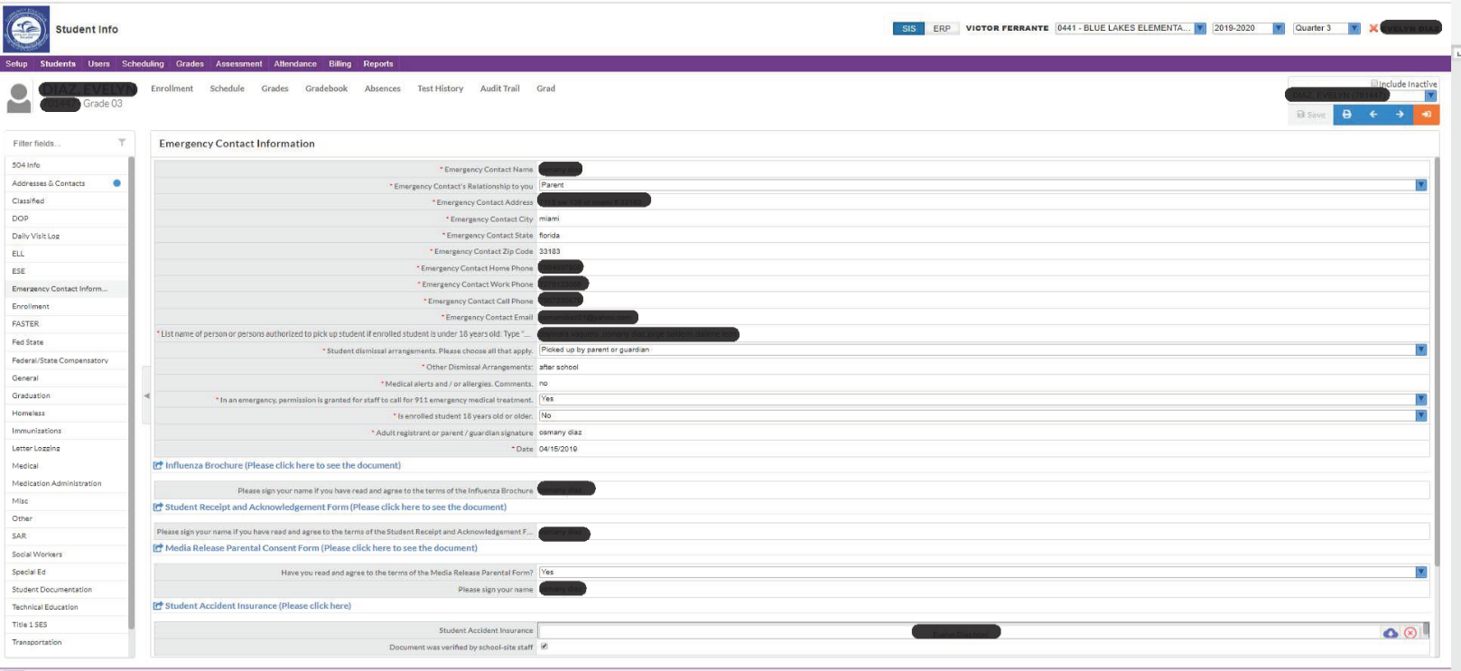

**FEE-BASED COMMUNITY EDUCATION AND**

**BEFORE / AFTER SCHOOL CARE PARENT HANDBOOK:**

**PROGRAM GUIDELINES**

**STUDENT ACCIDENT INSURANCE:** It is mandatory to obtain the HSR student accident insurance issued through the district. No child may participate in or attend the before and after school care program and select community education classes without this insurance. This is a supplemental insurance plan and it is required even if you already have family or individual medical insurance coverage. This supplemental insurance plan ***DOES NOT*** take the place of family or individual medical insurance coverage. It is your responsibility to become familiar with any insurance limitations and other information provided through this insurance. If you have any questions about student accident insurance, please contact the M-DCPS Office of Risk & Benefits Management AT (305) 995-7129.

Students that wish to enroll in a Before care • After care • Story Hour • Summer program and certain community education classes without verified proof of the required Health Special Risk, Inc. (HSR) Student Accident Insurance will not be considered registered for a program or class even if they have paid for the program or class. Students without the HSR Student Accident Insurance will not be able to participate or attend the program if the program they have paid for or signed up for requires it.

To login or to open a new account and pay online for the required Health Special Risk, Inc. (HSR) Student Accident Insurance please go to the following website

* <https://www.hsri.com/K12_Enrollment/Main/newAccount.asp>

Please make sure that you or your child uploads the paid HSR receipt in FOCUS or delivers a copy of it to the main office to be able to attend or participate in the program.

It is extremely important that you immediately notify the before and/or after school care program manager if you have made any changes on your child’s online registration.

Registration Documents: Must be completed before a student can participate in a program.

Failure to complete your child’s registration information can result in your child being excluded from the program.

**FEE-BASED COMMUNITY EDUCATION AND**

**BEFORE / AFTER SCHOOL CARE PARENT HANDBOOK:**

**PROGRAM GUIDELINES**

**PROGRAM FEE PAYMENTS:** After registering you child in FOCUS, Parents will also have the option to pay for their child’s before / after school care program fees and any available enhancement classes offered at your school by check, cash, credit card or money order. **In person check, cash, or money order payments must be the in exact amount or you will be directed to your parent portal to pay via credit card.**

We strongly encourage parents or guardians to use their credit card online to pay for programs and classes as this process will expedite the enrollment process for your child’s next service period. Log into the districts:

M-DCPS Parent Portal website:

* <http://www.dadeschools.net/parents.asp>

Once in the Parent Portal, click on the “FOCUS” link:



FOCUS - REGISTRATION AND ONLINE PAYMENT SYSTEM FOR BEFORE / AFTER SCHOOL CARE PROGRAMS AND COMMUNITY EDUCATION CLASSES.

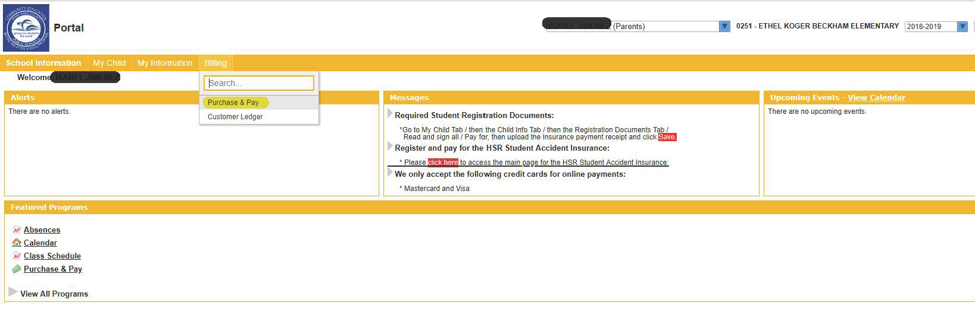

**FEE-BASED COMMUNITY EDUCATION AND**

**BEFORE / AFTER SCHOOL CARE PARENT HANDBOOK:**

**PROGRAM GUIDELINES**

Please remember to schedule and pay for each of your children if you have more than one and especially if they are assigned to a different school / grade / teacher / program / course / section / class.

Check, cash, credit card or money order payments made on “FOCUS” are applicable to your child’s Before care • After care • Story Hour • Summer program and school based and/or district offered Community Education enhancement classes. All program payments must be paid prior to the start of the payment service period or start of class. Payments must be paid in full, no partial payments are accepted. **In person check, cash, or money order payments must be the in exact amount or you will be directed to your parent portal to pay via credit card.**

* Before care • After care • Story Hour • Summer program and school based and/or district offered Community Education enhancement classes have a short window for parents / students to pay online (usually a week prior to the start date). Once a program or class payment period start date has been reached, you will need to come into the program office to pay in person if you wish for your child to continue in the program or class.
* ***NO CHILD WILL BE ALLOWED TO ATTEND A PROGRAM OR CLASS FOR WHICH A SERVICE PERIOD PAYMENT HAS NOT BEEN MADE UNLESS APPROVED BY THE PRINCIPAL OF THE SCHOOL.***

**LATE PICK UP FEE:** A late fee of $5.00, per student, per 15 minutes, will be charged for children not picked up on time. Consistently being charged a late pick up fee may result in the child being withdrawn from the program. All late pick-up fees will be added to your “FOCUS” account and must be paid prior to the start of the next payment period.

**LATE PAYMENT FEE:** A late payment fee of $5.00, per student, per incident, and per program, will be charged for payments that are not received prior to the start of the next service period. All late payment fees will be added to your “FOCUS” account and must be paid prior to the start of the next payment period.

**REFUND POLICY:** Only students that have been verified as absent for ***5 OR MORE CONSECUTIVE SERVICE DAYS*** from the before and/or after school program, may receive a refund for the number of paid days absent. Parents must notify the after-school care staff if their child will be absent on any given day.

**NON-SUFFICIENT FUNDS / RETURNED CHECKS:** If a check is returned for any reason to us for non-sufficient funds, we ***WILL NOT*** redeposit it. For your child to remain in the program, you will be required to bring only cash in the amount of the check and any additional service charge made by the bank, within 24 hours of notification. Should this happen more than once, we will ask that all your future payments be made in cash, money order, or online via credit card.

**FEE-BASED COMMUNITY EDUCATION AND**

**BEFORE / AFTER SCHOOL CARE PARENT HANDBOOK:**

**PROGRAM GUIDELINES**

**IRS FORM W-10 - DEPENDANT CARE PROVIDER’S IDENTIFICATION AND CERTIFICATION:** Certain program costs may be deducted from your federal income taxes and it is recommended that you save your cancelled checks and/or receipts that you receive from the program. Ask your Program Manager for the needed IRS W-10 form (Dependent Care Provider Identification and Certification) when you are ready to file.

**FREE OR REDUCED LUNCH STATUS:** Students who qualify and are verified as having free or reduced lunch status in “FOCUS” will be eligible for a reduced after school care rate (see page 2). Any increase or reduction in the student Free and Reduced lunch status rate during a student’s present service period will become effective and enforced starting on the first day of the next payment service period.

**ELC SUBSIDIZED CHILD CARE:**  Parents or guardians approved to receive subsidized child care through The Early Learning Coalition of Miami-Dade/Monroe (ELC) must adhere to the guidelines stipulated by this agency. Students approved to receive ELC funds may be eligible for a subsidized allotment that will off-set the cost for the after-school care program by up to:

**($8.00 per day – BASE max ELC part-time subsidy)**

**($12.00 per day – STAGE II max ELC part-time subsidy)**

and for the all-day school care program, up to:

**($19.67 per day – BASE max ELC full-time subsidy)**

**($21.64 per day – STAGE II max ELC full-time subsidy)**

Any increase or reduction in the student ELC voucher rate during a student’s present service period may become effective and enforced on the first day of the next payment service period.

Parents or guardians are responsible for program fees that are in excess of the subsidized voucher amount. If you are interested, the ELC can be reached at (305) 646-7220 from 8:00 am to 5:00 pm. For more information, go to [www.elcmdm.org](http://www.elcmdm.org)

**FEE-BASED COMMUNITY EDUCATION AND**

**BEFORE / AFTER SCHOOL CARE PARENT HANDBOOK:**

**PROGRAM GUIDELINES**

**RELEASE OF CHILDREN:** Children enrolled in after school care may be picked up any time prior to 6:00 p.m., but they must be picked up ***NO LATER*** than 6:00 p.m. If an emergency arises, you are expected to make arrangements so that your child will be picked up before 6:00 p.m. and to notify the after school care program manager accordingly. Parents who are unable to pick up their children on time, on a regular basis, may be susceptible to their child being withdrawn from the program.

**BEFORE SCHOOL ARRIVAL PROCEDURES:** If your child is enrolled in a Before care program, the child must be signed in daily within the school building by an authorized person listed on the child’s registration form.

# DISMISSAL PROCEDURES: (Please adhere to School’s Stage II plan)

**Parent sign-out and pick-up:** Each after school care child must be signed out from the after school care office by an ***AUTHORIZED PERSON*** listed on the child’s registration form. The authorized person may be asked to present an official government photo identification card; i.e. driver’s license, state ID, military ID, alien registration card, or passport. Once the ID is verified, a pick-up pass will be issued enabling the authorized person to retrieve their child directly from the designated employee(s) assigned to release that school sites after school care students. Any other person that is not listed on the child’s registration form must display permission in writing from the parent or legal guardian and be able to present an official government photo identification card that has been verified by an authorized school employee before the child can be released.

**Authorized Persons:** ***ONLY*** those persons listed on your child’s registration form are considered authorized. Family members, if not listed, are not considered authorized to pick up your child. Verification by the after school care program manager or designee will be made before any child is released to a person not listed on the registration form.

**Walk Home:** A written notification must be kept on file or sent the same day that your child is to walk home. The time of departure must be specified in the written notification. The administrator or after school care program manager must approve the child’s departure.

**Absent Students**: Parents or guardians whose child or children are absent from the After School Care Program and are not listed on the day schools absentee list will be contacted as expediently as possible. Parents must notify the after school care office if their child will be absent on any given day.

**Changes in Dismissal Procedures:** If there are any changes in the dismissal procedures for your child, daily or continuous, please notify the after school care office in person or in writing immediately. This will help to ensure the safety of your child. If, for whatever reason, you pick your child up early from the regular day school program, please contact the before and/or after school care program office as expediently as possible. Parents must notify the after school care office if their child will be absent on any given day.

All of these procedures are in place to help ensure the safety of all children attending the program.

**FEE-BASED COMMUNITY EDUCATION AND**

**BEFORE / AFTER SCHOOL CARE PARENT HANDBOOK:**

**PROGRAM GUIDELINES**

**ILLNESS / ACCIDENTS:** Should your child become ill or injured during the program, you will be notified immediately and if needed you must make arrangements to pick up your child at that time.

**SPECIAL NEEDS:** If there are special needs by way of accommodations pursuant to the Americanswith Disabilities Act, please consult with your school site administrator. Parents or guardians that are in need of additional information or resources may call the Miami-Dade County Public Schools Division of Special Education and Student Support or the Office of Community Education and Before/After School Programs using the following phone numbers or by going to the following website found at <http://ese.dadeschools.net>:

305-995-2707 • Main line for the Division of Special Education

and Student Support

Website: ESE.DADESCHOOLS.NET

Email address: [ESE235@DADESCHOOLS.NET](mailto:ESE235@DADESCHOOLS.NET)

305-995-2037 • Ms. Ava Goldman, Administrative Director, Division of Special Education

and Student Support

[AGOLDMAN@DADESCHOOLS.NET](mailto:AGOLDMAN@DADESCHOOLS.NET)

305-817-0014 • Mr. Victor Ferrante, Executive Director,

Community Education and Before/After School Programs

[VICFERRANTE@DADESCHOOLS.NET](mailto:VICFERRANTE@DADESCHOOLS.NET)

**MEDICAL AUTHORIZATION:** Should your child require self-medication during the hours that he/she attends the program, a permission form must be filled out and kept on file. Please notify the before and/or after school care program manager should that occasion arise.

**FEE-BASED COMMUNITY EDUCATION AND**

**BEFORE / AFTER SCHOOL CARE PARENT HANDBOOK:**

**PROGRAM GUIDELINES**

**CODE OF STUDENT CONDUCT:** Your child will be under the supervision of qualified personnel familiar with his/her school. The Miami-Dade County Public Schools Code of Student Conduct which is utilized during the day school program will also be utilized during the before and after school programs. Behavioral policies will be explained to your child. For additional information on the Code of Student Conduct you can go to the following website:

* <http://ehandbooks.dadeschools.net/policies/90/>

**MAINTENANCE OF APPROPRIATE STUDENT BEHAVIOR:** The schools are established for the benefit of all students. The educational purposes of the schools are accomplished best in a climate of student behavior that is socially acceptable and conducive to the learning and teaching process. Student behavior that disrupts this process or that infringes upon the rights of other individuals will not be tolerated. The School Board of Miami-Dade County, Florida, endorses a zero tolerance policy toward school related violent crime. The Board reaffirms its support of the administrative staff and teachers in taking all necessary steps to enforce and implement all Board rules pertaining to the maintenance of appropriate student behavior. Important among these rules are those in the areas of conduct, corporal punishment, suspensions, expulsions, and climate for learning.

Interested parties may refer to the following Miami-Dade County Public School guides:

* Code of Student Conduct
* Procedures for Promoting and Maintaining a Safe Learning Environment
* Local Education Agency (LEA) Implementation Guide”

2020 - 2021

SCHOOL CALENDARS



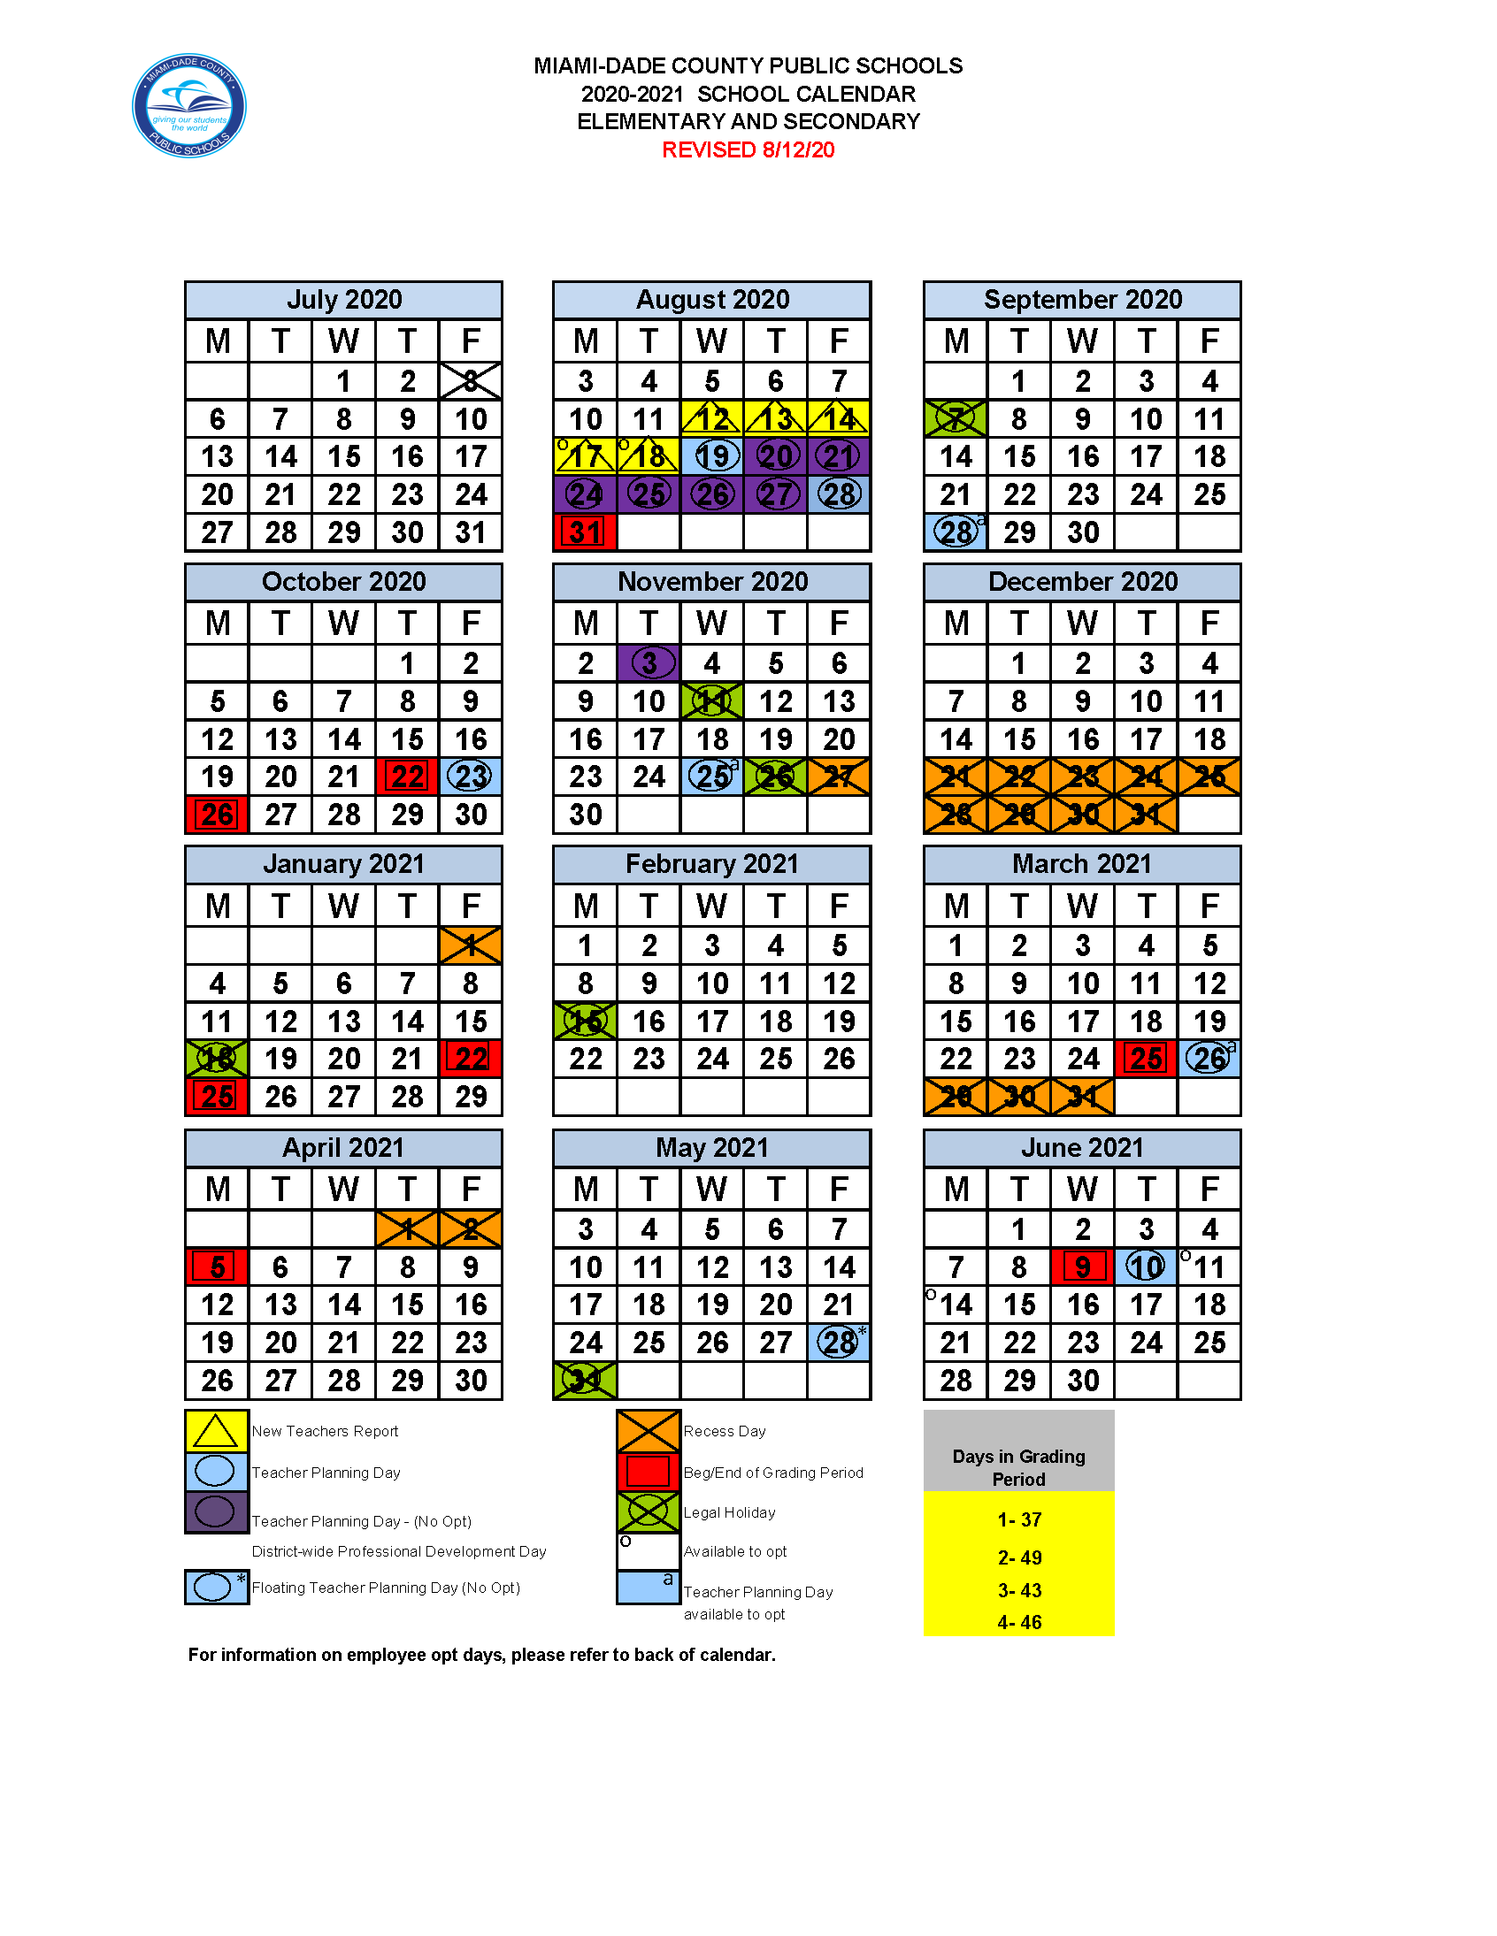

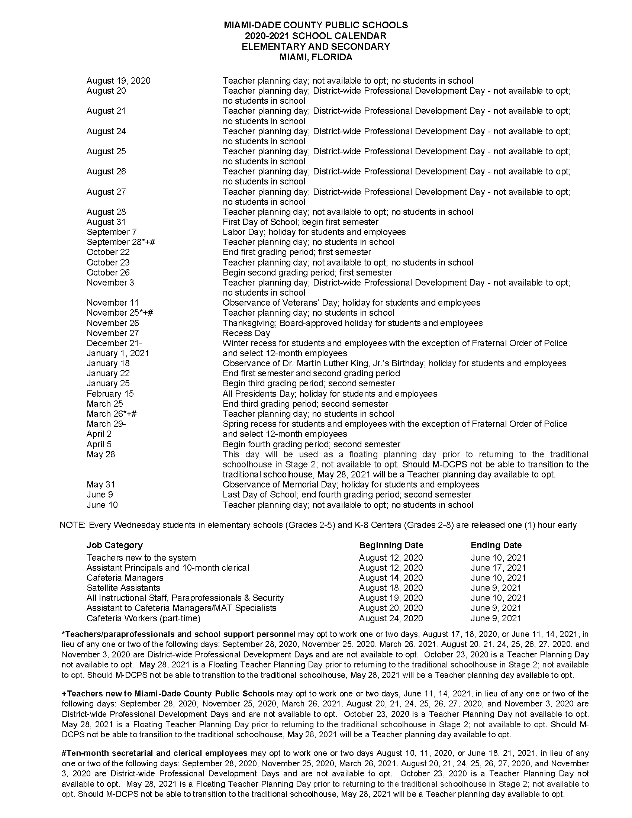



**PAY ONLINE FOR AFTER CARE USING A CREDIT CARD ON THE FOCUS PARENT PORTAL!**

2020 - 2021

ONLINE STUDENT REGISTRATION, SCHEDULING, COURSE SELECTION, AND PAYMENTS



**ELEMENTARY AND K-8 CENTERS**

**2020 - 2021 ANNUAL PROGRAM**

**10 DAY SERVICE PERIODS – ANNUAL PAYMENT SCHEDULE**

**OPERATES FROM MONDAY, AUGUST 24, 2020 THROUGH WEDNESDAY, JUNE 09, 2021**

**SCHOOL NAME: ADD SCHOOL NAME xxxxxxxxxxxxxxxxxxxxxxxxxxxxxxxxxxxxxxxxxxxxxxxxxxx**

1

|  |  |  |  |  |  |  |  |
| --- | --- | --- | --- | --- | --- | --- | --- |
| **PAYMENT**  **START**  **DATES** | **BASE RATES**    **10 DAY**  **SERVICE PERIODS** | **NUMBER**  **OF**  **SERVICE**  **DAYS PER**  **SERVICE PERIOD** | **PER STUDENT FEE FOR EACH**  **SERVICE PERIOD AND PROGRAM** | | | | |
| **BEFORE SCHOOL PROGRAM**  **BEFORE CARE**  **$4.00**  **RATE**  **MTWTF** | **AFTER SCHOOL**  **PROGRAM**  **STORY**  **HOUR**  **$4.00**  **RATE**  **MTWTF** | **AFTER SCHOOL**  **PROGRAM**  **FREE OR REDUCED LUNCH**  **$7.00**  **RATE**  **MTWTF** | **AFTER SCHOOL**  **PROGRAM**  **REGULAR**  **$8.00**  **RATE**  **MTWTF** |  |

1

|  |  |  |  |  |  |  |  |
| --- | --- | --- | --- | --- | --- | --- | --- |
| **MONDAY, AUGUST 17** | **AUG. 24 TO SEPT. 04** | **10** | **$40.00** | **$40.00** | **$70.00** | **$80.00** |  |
| **MONDAY, AUGUST 31** | **SEPT. 08 TO SEPT. 21** | **10** | **$40.00** | **$40.00** | **$70.00** | **$80.00** |  |
| **MONDAY, SEPTEMBER 14** | **SEPT. 22 TO OCT. 06** | **10** | **$40.00** | **$40.00** | **$70.00** | **$80.00** |  |
| **MONDAY, SEPTEMBER 28** | **OCT. 07 TO OCT. 20** | **10** | **$40.00** | **$40.00** | **$70.00** | **$80.00** |  |
| **MONDAY, OCTOBER 12** | **OCT. 21 TO NOV. 05** | **10** | **$40.00** | **$40.00** | **$70.00** | **$80.00** |  |
| **MONDAY, OCTOBER 26** | **NOV. 06 TO NOV. 20** | **10** | **$40.00** | **$40.00** | **$70.00** | **$80.00** |  |
| **MONDAY, NOVEMBER 16** | **NOV. 23 TO DEC. 09** | **10** | **$40.00** | **$40.00** | **$70.00** | **$80.00** |  |
| **MONDAY, NOVEMBER 30** | **DEC. 10 TO JAN. 06** | **10** | **$40.00** | **$40.00** | **$70.00** | **$80.00** |  |
| **MONDAY, DECEMBER 28** | **JAN. 07 TO JAN. 21** | **10** | **$40.00** | **$40.00** | **$70.00** | **$80.00** |  |
| **MONDAY, JANUARY 18** | **JAN. 22 TO FEB. 04** | **10** | **$40.00** | **$40.00** | **$70.00** | **$80.00** |  |
| **MONDAY, FEBRUARY 01** | **FEB. 05 TO FEB. 19** | **10** | **$40.00** | **$40.00** | **$70.00** | **$80.00** |  |
| **MONDAY, FEBRUARY 15** | **FEB. 22 TO MAR. 05** | **10** | **$40.00** | **$40.00** | **$70.00** | **$80.00** |  |
| **MONDAY, MARCH 01** | **MAR. 08 TO MAR. 19** | **10** | **$40.00** | **$40.00** | **$70.00** | **$80.00** |  |
| **MONDAY, MARCH 15** | **MAR. 22 TO APR. 12** | **10** | **$40.00** | **$40.00** | **$70.00** | **$80.00** |  |
| **MONDAY, APRIL 05** | **APR. 13 TO APR. 26** | **10** | **$40.00** | **$40.00** | **$70.00** | **$80.00** |  |
| **MONDAY, APRIL 19** | **APR. 27 TO MAY 10** | **10** | **$40.00** | **$40.00** | **$70.00** | **$80.00** |  |
| **MONDAY, MAY 03** | **MAY 11 TO MAY 24** | **10** | **$40.00** | **$40.00** | **$70.00** | **$80.00** |  |
| **MONDAY, MAY 17** | **MAY 25 TO JUNE 09** | **10** | **$40.00** | **$40.00** | **$70.00** | **$80.00** |  |
|  | **18 SERVICE**  **PERIODS** | **180**  **SERVICE**  **DAYS** | **REGULAR**  **STUDENT**  **RATE IS**  **$4.00** | **REGULAR**  **STUDENT RATE IS**  **$4.00** | **FREE AND**  **REDUCED**  **LUNCH STUDENT**  **RATE IS**  **$7.00** | **REGULAR STUDENT**  **RATE IS**  **$8.00** |  |

**ELEMENTARY AND K-8 CENTERS**

**2020 - 2021 ANNUAL PROGRAM**

**20 DAY SERVICE PERIODS – ANNUAL PAYMENT SCHEDULE**

**OPERATES FROM MONDAY, AUGUST 24, 2020 THROUGH WEDNESDAY, JUNE 09, 2021**

**NOTE: PLEASE REFER TO PAGE 22 FOR STAGE 2 RATES AND PAYMENT SCHEDULE**

**SCHOOL NAME: CALUSA ELEMENTARY SCHOOL**

|  |  |  |  |  |  |  |  |
| --- | --- | --- | --- | --- | --- | --- | --- |
| **PAYMENT**  **START**  **DATES** | **BASE RATES**    **20 DAY**  **SERVICE PERIODS** | **NUMBER**  **OF**  **SERVICE**  **DAYS PER**  **SERVICE PERIOD** | **PER STUDENT FEE FOR EACH**  **SERVICE PERIOD AND PROGRAM** | | | | |
| **BEFORE SCHOOL PROGRAM**  **BEFORE CARE**  **$4.00**  **RATE**  **MTWTF** | **AFTER SCHOOL**  **PROGRAM**  **STORY**  **HOUR**  **$4.00**  **RATE**  **MTWTF** | **AFTER SCHOOL**  **PROGRAM**  **FREE OR REDUCED LUNCH**  **$7.00**  **RATE**  **MTWTF** | **AFTER SCHOOL**  **PROGRAM**  **REGULAR**  **$8.00**  **RATE**  **MTWTF** |  |

1

1

|  |  |  |  |  |  |  |  |
| --- | --- | --- | --- | --- | --- | --- | --- |
| **MONDAY, AUGUST 17** | **AUG. 24 TO SEPT. 21** | **20** | **$80.00** | **$80.00** | **$140.00** | **$160.00** |  |
|  |  |  |  |  |  |  |  |
| **MONDAY, SEPTEMBER 14** | **SEPT. 22 TO OCT. 20** | **20** | **$80.00** | **$80.00** | **$140.00** | **$160.00** |  |
|  |  |  |  |  |  |  |  |
| **MONDAY, OCTOBER 12** | **OCT. 21 TO NOV. 20** | **20** | **$80.00** | **$80.00** | **$140.00** | **$160.00** |  |
|  |  |  |  |  |  |  |  |
| **MONDAY, NOVEMBER 16** | **NOV. 23 TO JAN. 06** | **20** | **$80.00** | **$80.00** | **$140.00** | **$160.00** |  |
|  |  |  |  |  |  |  |  |
| **MONDAY, DECEMBER 28** | **JAN. 07 TO FEB. 04** | **20** | **$80.00** | **$80.00** | **$140.00** | **$160.00** |  |
|  |  |  |  |  |  |  |  |
| **MONDAY, FEBRUARY 01** | **FEB. 05 TO MAR. 05** | **20** | **$80.00** | **$80.00** | **$140.00** | **$160.00** |  |
|  |  |  |  |  |  |  |  |
| **MONDAY, MARCH 01** | **MAR. 08 TO APR. 12** | **20** | **$80.00** | **$80.00** | **$140.00** | **$160.00** |  |
|  |  |  |  |  |  |  |  |
| **MONDAY, APRIL 05** | **APR. 13 TO MAY 10** | **20** | **$80.00** | **$80.00** | **$140.00** | **$160.00** |  |
|  |  |  |  |  |  |  |  |
| **MONDAY, MAY 03** | **MAY 11 TO JUNE 09** | **20** | **$80.00** | **$80.00** | **$140.00** | **$160.00** |  |
|  |  |  |  |  |  |  |  |
|  | **09 SERVICE**  **PERIODS** | **180**  **SERVICE**  **DAYS** | **REGULAR**  **STUDENT**  **RATE IS**  **$4.00** | **REGULAR**  **STUDENT RATE IS**  **$4.00** | **FREE AND**  **REDUCED**  **LUNCH STUDENT**  **RATE IS**  **$7.00** | **REGULAR STUDENT**  **RATE IS**  **$8.00** |  |

**ELEMENTARY AND K-8 CENTERS**

**2021 SUMMER PROGRAM**

**10 DAY SERVICE PERIODS – SUMMER PAYMENT SCHEDULE**

**RANGE OF OPERATION IS FROM MONDAY, JUNE 14, 2021 THROUGH FRIDAY, AUGUST 20, 2021**

**SCHOOL NAME: ADD SCHOOL NAME xxxxxxxxxxxxxxxxxxxxxxxxxxxxxxxxxxxxxxxxxxxxxxxxxxx**

|  |  |  |  |  |  |  |  |  |
| --- | --- | --- | --- | --- | --- | --- | --- | --- |
| **PAYMENT**  **START**  **DATES** | **BASE RATES**    **10 DAY**  **SERVICE PERIODS** | **NUMBER**  **OF**  **DAYS IN**  **EACH**  **SERVICE**  **PERIOD** | **PER STUDENT FEE FOR EACH**  **SERVICE PERIOD AND PROGRAM** | | | | | |
| **SUMMER**  **AFTER SCHOOL**  **PROGRAM**  **FREE OR REDUCED LUNCH**  **$7.00**  **RATE MTWTF** | **SUMMER**  **AFTER SCHOOL**  **PROGRAM**  **REGULAR**  **$8.00 RATE MTWTF** | **SUMMER CAMP**  **PROGRAM**  **HALF-DAY FREE OR REDUCED LUNCH**  **$11.00 RATE MTWTF** | **SUMMER CAMP**  **PROGRAM**  **HALF-DAY**  **REGULAR**  **$12.00 RATE MTWTF** | **SUMMER CAMP**  **PROGRAM**  **ALL-DAY**  **FREE OR REDUCED LUNCH**  **$18.00 RATE**  **MTWTF** | **SUMMER CAMP**  **PROGRAM**  **ALL-DAY**  **REGULAR**  **$20.00 RATE**  **MTWTF** |

1

|  |  |  |  |  |  |  |  |  |
| --- | --- | --- | --- | --- | --- | --- | --- | --- |
| **MONDAY, JUNE 07** | **JUNE 14 TO JUNE 25** | **10** | **$70.00** | **$80.00** | **$110.00** | **$120.00** | **$180.00** | **$200.00** |
| **MONDAY, JUNE 21** | **JUNE 28 TO JUNE 30** | **03 ◄** | **$21.00** | **$24.00** | **$33.00** | **$36.00** | **$54.00** | **$60.00** |
| **MONDAY, JULY 01** | **JULY 01 TO JULY 15** | **10** | **$70.00** | **$80.00** | **$110.00** | **$120.00** | **$180.00** | **$200.00** |
| **MONDAY, JULY 12** | **JULY 16 TO JULY 29** | **10** | **$70.00** | **$80.00** | **$110.00** | **$120.00** | **$180.00** | **$200.00** |
| **MONDAY, JULY 19** | **JULY 30 TO AUG. 12** | **10** | **$70.00** | **$80.00** | **$110.00** | **$120.00** | **$180.00** | **$200.00** |
| **MONDAY, AUG 02** | **AUG. 13 TO AUG. 20** | **06 ◄** | **$42.00** | **$48.00** | **$66.00** | **$72.00** | **$108.00** | **$120.00** |
|  |  |  |  |  |  |  |  |  |
|  | **05 SERVICE**  **PERIODS** | **49 SERVICE DAYS** | **FREE AND**  **REDUCED**  **LUNCH STUDENT**  **RATE IS**  **$7.00** | **REGULAR STUDENT RATE IS**  **$8.00** | **FREE AND**  **REDUCED**  **LUNCH STUDENT RATE IS**  **$11.00** | **REGULAR STUDENT RATE IS**  **$12.00** | **FREE AND**  **REDUCED**  **LUNCH STUDENT RATE IS**  **$18.00** | **REGULAR STUDENT**  **RATE IS**  **$20.00** |

1

**ELEMENTARY AND K-8 CENTERS**

**2021 SUMMER PROGRAM**

**20 DAY SERVICE PERIODS – SUMMER PAYMENT SCHEDULE**

**RANGE OF OPERATION IS FROM MONDAY, JUNE 14, 2021 THROUGH FRIDAY, AUGUST 20, 2021**

**SCHOOL NAME: ADD SCHOOL NAME xxxxxxxxxxxxxxxxxxxxxxxxxxxxxxxxxxxxxxxxxxxxxxxxxxx**

**BASE RATES**

|  |  |  |  |  |  |  |  |  |
| --- | --- | --- | --- | --- | --- | --- | --- | --- |
| **PAYMENT**  **START**  **DATES** | **20 DAY**  **SERVICE PERIODS** | **NUMBER**  **OF**  **DAYS IN**  **EACH**  **SERVICE**  **PERIOD** | **PER STUDENT FEE FOR EACH**  **SERVICE PERIOD AND PROGRAM** | | | | | |
| **SUMMER**  **AFTER SCHOOL**  **PROGRAM**  **FREE OR REDUCED LUNCH**  **$7.00**  **RATE MTWTF** | **SUMMER**  **AFTER SCHOOL**  **PROGRAM**  **REGULAR**  **$8.00 RATE MTWTF** | **SUMMER CAMP**  **PROGRAM**  **HALF-DAY FREE OR REDUCED LUNCH**  **$11.00 RATE MTWTF** | **SUMMER CAMP**  **PROGRAM**  **HALF-DAY**  **REGULAR**  **$12.00 RATE MTWTF** | **SUMMER CAMP**  **PROGRAM**  **ALL-DAY**  **FREE OR REDUCED LUNCH**  **$18.00 RATT**  **MTWRF** | **SUMMER CAMP**  **PROGRAM**  **ALL-DAY**  **REGULAR**  **$20.00 RATE**  **MTWTF** |

1

|  |  |  |  |  |  |  |  |  |
| --- | --- | --- | --- | --- | --- | --- | --- | --- |
| **MONDAY, JUNE 07** | **JUNE 14 TO JUNE 30** | **13 ◄** | **$91.00** | **$104.00** | **$143.00** | **$156.00** | **$234.00** | **$260.00** |
| **MONDAY, JULY 01** | **JULY 01 TO JULY 29** | **20** | **$140.00** | **$160.00** | **$120.00** | **$240.00** | **$360.00** | **$400.00** |
| **MONDAY, JULY 20** | **JULY 30 TO AUG. 20** | **16 ◄** | **$84.00** | **$96.00** | **$132.00** | **$144.00** | **$216.00** | **$240.00** |
|  | **03 SERVICE**  **PERIODS** | **49 SERVICE DAYS** | **FREE AND**  **REDUCED**  **LUNCH STUDENT**  **RATE IS**  **$7.00** | **REGULAR STUDENT RATE IS**  **$8.00** | **FREE AND**  **REDUCED**  **LUNCH STUDENT RATE IS**  **$11.00** | **REGULAR STUDENT RATE IS**  **$12.00** | **FREE AND**  **REDUCED**  **LUNCH STUDENT RATE IS**  **$18.00** | **REGULAR STUDENT**  **RATE IS**  **$20.00** |

**ELEMENTARY AND K-8 CENTERS – STAGE II**

**2020 - 2021 ANNUAL PROGRAM - STAGE II ONLY**

**10 DAY SERVICE PERIODS – STAGE II ANNUAL PAYMENT SCHEDULE**

**OPERATES FROM MONDAY, AUGUST 24, 2020 THROUGH WEDNESDAY, JUNE 09, 2021**

**SCHOOL NAME: ADD SCHOOL NAME xxxxxxxxxxxxxxxxxxxxxxxxxxxxxxxxxxxxxxxxxxxxxxxxxxx**

1

|  |  |  |  |  |  |  |  |
| --- | --- | --- | --- | --- | --- | --- | --- |
| **PAYMENT**  **START**  **DATES** | **10 DAY**  **SERVICE PERIODS**  **STAGE II RATES** | **NUMBER**  **OF**  **SERVICE**  **DAYS PER**  **SERVICE PERIOD** | **PER STUDENT FEE FOR EACH**  **SERVICE PERIOD AND PROGRAM** | | | | |
| **BEFORE SCHOOL PROGRAM**  **BEFORE CARE**  **$6.00**  **STAGE II**  **RATE**  **MTWTF** | **AFTER SCHOOL**  **PROGRAM**  **STORY**  **HOUR**  **$6.00**  **STAGE II RATE**  **MTWTF** | **AFTER SCHOOL**  **PROGRAM**  **FREE OR REDUCED LUNCH**  **$11.00**  **STAGE II RATE**  **MTWTF** | **AFTER SCHOOL**  **PROGRAM**  **REGULAR**  **$12.00**  **STAGE II RATE**  **MTWTF** |  |

1

|  |  |  |  |  |  |  |  |
| --- | --- | --- | --- | --- | --- | --- | --- |
| **MONDAY, AUGUST 17** | **AUG. 24 TO SEPT. 04** | **10** | **$60.00** | **$60.00** | **$110.00** | **$120.00** |  |
| **MONDAY, AUGUST 31** | **SEPT. 08 TO SEPT. 21** | **10** | **$60.00** | **$60.00** | **$110.00** | **$120.00** |  |
| **MONDAY, SEPTEMBER 14** | **SEPT. 22 TO OCT. 06** | **10** | **$60.00** | **$60.00** | **$110.00** | **$120.00** |  |
| **MONDAY, SEPTEMBER 28** | **OCT. 07 TO OCT. 20** | **10** | **$60.00** | **$60.00** | **$110.00** | **$120.00** |  |
| **MONDAY, OCTOBER 12** | **OCT. 21 TO NOV. 05** | **10** | **$60.00** | **$60.00** | **$110.00** | **$120.00** |  |
| **MONDAY, OCTOBER 26** | **NOV. 06 TO NOV. 20** | **10** | **$60.00** | **$60.00** | **$110.00** | **$120.00** |  |
| **MONDAY, NOVEMBER 16** | **NOV. 23 TO DEC. 09** | **10** | **$60.00** | **$60.00** | **$110.00** | **$120.00** |  |
| **MONDAY, NOVEMBER 30** | **DEC. 10 TO JAN. 06** | **10** | **$60.00** | **$60.00** | **$110.00** | **$120.00** |  |
| **MONDAY, DECEMBER 28** | **JAN. 07 TO JAN. 21** | **10** | **$60.00** | **$60.00** | **$110.00** | **$120.00** |  |
| **MONDAY, JANUARY 18** | **JAN. 22 TO FEB. 04** | **10** | **$60.00** | **$60.00** | **$110.00** | **$120.00** |  |
| **MONDAY, FEBRUARY 01** | **FEB. 05 TO FEB. 19** | **10** | **$60.00** | **$60.00** | **$110.00** | **$120.00** |  |
| **MONDAY, FEBRUARY 15** | **FEB. 22 TO MAR. 05** | **10** | **$60.00** | **$60.00** | **$110.00** | **$120.00** |  |
| **MONDAY, MARCH 01** | **MAR. 08 TO MAR. 19** | **10** | **$60.00** | **$60.00** | **$110.00** | **$120.00** |  |
| **MONDAY, MARCH 15** | **MAR. 22 TO APR. 12** | **10** | **$60.00** | **$60.00** | **$110.00** | **$120.00** |  |
| **MONDAY, APRIL 05** | **APR. 13 TO APR. 26** | **10** | **$60.00** | **$60.00** | **$110.00** | **$120.00** |  |
| **MONDAY, APRIL 19** | **APR. 27 TO MAY 10** | **10** | **$60.00** | **$60.00** | **$110.00** | **$120.00** |  |
| **MONDAY, MAY 03** | **MAY 11 TO MAY 24** | **10** | **$60.00** | **$60.00** | **$110.00** | **$120.00** |  |
| **MONDAY, MAY 17** | **MAY 25 TO JUNE 09** | **10** | **$60.00** | **$60.00** | **$110.00** | **$120.00** |  |
|  | **18 SERVICE**  **PERIODS** | **180**  **SERVICE**  **DAYS** | **REGULAR**  **STUDENT**  **STAGE II**  **RATE IS**  **$8.00** | **REGULAR**  **STUDENT STAGE II**  **RATE IS**  **$8.00** | **FREE AND**  **REDUCED**  **LUNCH STUDENT STAGE II**  **RATE IS**  **$14.00** | **REGULAR STUDET**  **STAGE II**  **RATE IS**  **$16.00** |  |

**ELEMENTARY AND K-8 CENTERS – STAGE II**

**2020 - 2021 ANNUAL PROGRAM – STAGE II ONLY**

**20 DAY SERVICE PERIODS – STAGE II ANNUAL PAYMENT SCHEDULE**

**OPERATES FROM MONDAY, AUGUST 24, 2020 THROUGH WEDNESDAY, JUNE 09, 2021**

**NOTE: RATES RETURN TO NORMAL (SEE PAGE 18) IN STAGE 3**

**SCHOOL NAME: ADD SCHOOL NAME xxxxxxxxxxxxxxxxxxxxxxxxxxxxxxxxxxxxxxxxxxxxxxxxxxx**

|  |  |  |  |  |  |  |  |
| --- | --- | --- | --- | --- | --- | --- | --- |
| **PAYMENT**  **START**  **DATES** | **20 DAY**  **SERVICE PERIODS**  **STAGE II RATES** | **NUMBER**  **OF**  **SERVICE**  **DAYS PER**  **SERVICE PERIOD** | **PER STUDENT FEE FOR EACH**  **SERVICE PERIOD AND PROGRAM** | | | | |
| **BEFORE SCHOOL PROGRAM**  **BEFORE CARE**  **$6.00**  **STAGE II RATE**  **MTWTF** | **AFTER SCHOOL**  **PROGRAM**  **5 DAY STORY**  **HOUR**  **$6.00**  **STAGE II RATE**  **MTWTF** | **AFTER SCHOOL**  **PROGRAM**  **FREE OR REDUCED LUNCH**  **$11.00**  **STAGE II RATE**  **MTWTF** | **AFTER SCHOOL**  **PROGRAM**  **REGULAR**  **$12.00**  **STAGE II RATE**  **MTWTF** |  |

1

1

|  |  |  |  |  |  |  |  |
| --- | --- | --- | --- | --- | --- | --- | --- |
| **MONDAY, AUGUST 17** | **AUG. 24 TO SEPT. 21** | **20** | **$120.00** | **$120.00** | **$220.00** | **$240.00** |  |
|  |  |  |  |  |  |  |  |
| **MONDAY, SEPTEMBER 14** | **SEPT. 22 TO OCT. 20** | **20** | **$120.00** | **$120.00** | **$220.00** | **$240.00** |  |
|  |  |  |  |  |  |  |  |
| **MONDAY, OCTOBER 12** | **OCT. 21 TO NOV. 20** | **20** | **$120.00** | **$120.00** | **$220.00** | **$240.00** |  |
|  |  |  |  |  |  |  |  |
| **MONDAY, NOVEMBER 16** | **NOV. 23 TO JAN. 06** | **20** | **$120.00** | **$120.00** | **$220.00** | **$240.00** |  |
|  |  |  |  |  |  |  |  |
| **MONDAY, DECEMBER 28** | **JAN. 07 TO FEB. 04** | **20** | **$120.00** | **$120.00** | **$220.00** | **$240.00** |  |
|  |  |  |  |  |  |  |  |
| **MONDAY, FEBRUARY 01** | **FEB. 05 TO MAR. 05** | **20** | **$120.00** | **$120.00** | **$220.00** | **$240.00** |  |
|  |  |  |  |  |  |  |  |
| **MONDAY, MARCH 01** | **MAR. 08 TO APR. 12** | **20** | **$120.00** | **$120.00** | **$220.00** | **$240.00** |  |
|  |  |  |  |  |  |  |  |
| **MONDAY, APRIL 05** | **APR. 13 TO MAY 10** | **20** | **$120.00** | **$120.00** | **$220.00** | **$240.00** |  |
|  |  |  |  |  |  |  |  |
| **MONDAY, MAY 03** | **MAY 11 TO JUNE 09** | **20** | **$120.00** | **$120.00** | **$220.00** | **$240.00** |  |
|  |  |  |  |  |  |  |  |
|  | **09 SERVICE**  **PERIODS** | **180**  **SERVICE**  **DAYS** | **REGULAR**  **STAGEII II STUDENT**  **STAGE II**  **RATE IS**  **$8.00** | **REGULAR**  **STUDENT STAGE II II RATE IS**  **$8.00** | **FREE AND**  **REDUCED**  **LUNCH**  **STUDENT STAGE II**  **RATE IS**  **$14.00** | **REGULAR STUDENT STAGE II**  **RATE IS**  **16.00** |  |

**ELEMENTARY AND K-8 CENTERS – STAGE II**

**2021 SUMMER PROGRAM – STAGE II ONLY**

**10 DAY SERVICE PERIODS – STAGE II SUMMER PAYMENT SCHEDULE**

**RANGE OF OPERATION IS FROM MONDAY, JUNE 14, 2021 THROUGH FRIDAY, AUGUST 20, 2021**

**SCHOOL NAME: ADD SCHOOL NAME xxxxxxxxxxxxxxxxxxxxxxxxxxxxxxxxxxxxxxxxxxxxxxxxxxx**

|  |  |  |  |  |  |  |  |  |
| --- | --- | --- | --- | --- | --- | --- | --- | --- |
| **PAYMENT**  **START**  **DATES** | **10 DAY**  **SERVICE PERIODS**  **STAGE II RATES** | **NUMBER**  **OF**  **DAYS IN**  **EACH**  **SERVICE**  **PERIOD** | **PER STUDENT FEE FOR EACH**  **SERVICE PERIOD AND PROGRAM** | | | | | |
| **SUMMER**  **AFTER SCHOOL**  **PROGRAM**  **FREE OR REDUCED LUNCH**  **$11.00**  **STAGE II**  **RATE MTWTF** | **SUMMER**  **AFTER SCHOOL**  **PROGRAM**  **REGULAR**  **$12.00 STAGE II**  **RATE MTWTF** | **SUMMER CAMP**  **PROGRAM**  **HALF-DAY FREE OR REDUCED LUNCH**  **$17.00 STAGE II**  **RATE MTWTF** | **SUMMER CAMP**  **PROGRAM**  **HALF-DAY**  **REGULAR**  **$18.00 STAGE II**  **RATE MTWTF** | **SUMMER CAMP**  **PROGRAM**  **ALL-DAY**  **FREE OR REDUCED LUNCH**  **$28.00 STAGE II**  **RATE**  **MTWTF** | **SUMMER CAMP**  **PROGRAM**  **ALL-DAY**  **REGULAR**  **$30.00 STAGE II**  **RATE**  **MTWTF** |

1

|  |  |  |  |  |  |  |  |  |
| --- | --- | --- | --- | --- | --- | --- | --- | --- |
| **MONDAY, JUNE 07** | **JUNE 14 TO JUNE 25** | **10** | **$110.00** | **$120.00** | **$170.00** | **$180.00** | **$280.00** | **$300.00** |
| **MONDAY, JUNE 21** | **JUNE 28 TO JUNE 30** | **03 ◄** | **$33.00** | **$36.00** | **$51.00** | **$54.00** | **$84.00** | **$900.00** |
| **MONDAY, JULY 01** | **JULY 01 TO JULY 15** | **10** | **$110.00** | **$120.00** | **$170.00** | **$180.00** | **$280.00** | **$300.00** |
| **MONDAY, JULY 12** | **JULY 16 TO JULY 29** | **10** | **$110.00** | **$120.00** | **$170.00** | **$180.00** | **$280.00** | **$300.00** |
| **MONDAY, JULY 19** | **JULY 30 TO AUG. 12** | **10** | **$110.00** | **$120.00** | **$170.00** | **$180.00** | **$280.00** | **$300.00** |
| **MONDAY, AUG 02** | **AUG. 13 TO AUG. 20** | **06 ◄** | **$66.00** | **$72.00** | **$102.00** | **$108.00** | **$168.00** | **$180.00** |
|  |  |  |  |  |  |  |  |  |
|  | **06 SERVICE**  **PERIODS** | **49 SERVICE DAYS** | **FREE AND**  **REDUCED**  **LUNCH STUDENT**  **STAGE II**  **RATE IS**  **$14.00** | **REGULAR STUDENT STAGE II**  **RATE IS**  **$16.00** | **FREE AND**  **REDUCED**  **LUNCH STUDENT STAGE II**  **RATE IS**  **$22.00** | **REGULAR STUDENT STAGE II**  **RATE IS**  **$24.00** | **FREE AND**  **REDUCED**  **LUNCH STUDENT STAGE II**  **RATE IS**  **$36.00** | **REGULAR STUDENT**  **STAGE II**  **RATE IS**  **$40.00** |

1

**ELEMENTARY AND K-8 CENTERS – STAGE II**

**2021 SUMMER PROGRAM – STAGE II ONLY**

**20 DAY SERVICE PERIODS – STAGE II SUMMER PAYMENT SCHEDULE**

**RANGE OF OPERATION IS FROM MONDAY, JUNE 14, 2021 THROUGH FRIDAY, AUGUST 20, 2021**

**SCHOOL NAME: ADD SCHOOL NAME xxxxxxxxxxxxxxxxxxxxxxxxxxxxxxxxxxxxxxxxxxxxxxxxxxx**

|  |  |  |  |  |  |  |  |  |
| --- | --- | --- | --- | --- | --- | --- | --- | --- |
| **PAYMENT**  **START**  **DATES** | **20 DAY**  **SERVICE PERIODS**  **STAGE II RATES** | **NUMBER**  **OF**  **DAYS IN**  **EACH**  **SERVICE**  **PERIOD** | **PER STUDENT FEE FOR EACH**  **SERVICE PERIOD AND PROGRAM** | | | | | |
| **SUMMER**  **AFTER SCHOOL**  **PROGRAM**  **FREE OR REDUCED LUNCH**  **$11.00**  **STAGE II**  **RATE MTWTF** | **SUMMER**  **AFTER SCHOOL**  **PROGRAM**  **REGULAR**  **$12.00 STAGE II**  **RATE MTWTF** | **SUMMER CAMP**  **PROGRAM**  **HALF-DAY FREE OR REDUCED LUNCH**  **$17.00 STAGE II**  **RATE MTWTF** | **SUMMER CAMP**  **PROGRAM**  **HALF-DAY**  **REGULAR**  **$18.00 STAGE II**  **RATE MTWTF** | **SUMMER CAMP**  **PROGRAM**  **ALL-DAY**  **FREE OR REDUCED LUNCH**  **$28.00 STAGE II**  **RATE**  **MTWRF** | **SUMMER CAMP**  **PROGRAM**  **ALL-DAY**  **REGULAR**  **$30.00 STAGE II**  **RATE**  **MTWTF** |

1

|  |  |  |  |  |  |  |  |  |
| --- | --- | --- | --- | --- | --- | --- | --- | --- |
| **MONDAY, JUNE 07** | **JUNE 14 TO JUNE 30** | **13 ◄** | **$143.00** | **$156.00** | **$221.00** | **$234.00** | **$364.00** | **$390.00** |
| **MONDAY, JULY 01** | **JULY 01 TO JULY 29** | **20** | **$220.00** | **$240.00** | **$340.00** | **$360.00** | **$560.00** | **$600.00** |
| **MONDAY, JULY 20** | **JULY 30 TO AUG. 20** | **16 ◄** | **$176.00** | **$192.00** | **$272.00** | **$288.00** | **$448.00** | **$480.00** |
|  | **03 SERVICE**  **PERIODS** | **49 SERVICE DAYS** | **FREE AND**  **REDUCED**  **LUNCH STUDENT**  **STAGE II**  **RATE IS**  **14.00** | **REGULAR STUDENT STAGE II**  **RATE IS**  **16.00** | **FREE AND**  **REDUCED**  **LUNCH STUDENT STAGE II**  **RATE IS**  **$22.00** | **REGULAR STUDENT STAGE II**  **RATE IS**  **$24.00** | **FREE AND**  **REDUCED**  **LUNCH STUDENT STAGE II**  **RATE IS**  **$36.00** | **REGULAR STUDENT**  **STAGE II**  **RATE IS**  **$40.00** |

**2020 - 2021**

**PARENT/GUARDIAN SIGNATURE FORM FOR THE**

**RECEIPT AND ACKNOWLEDGEMENT OF THE COMMUNITY EDUCATION AND**

**BEFORE/AFTER SCHOOL CARE PARENT HANDBOOK**

**SCHOOL NAME: CALUSA ELEMENTARY SCHOOL**

**I verify that I have received, read, and acknowledge the program guidelines and policies outlined in the Community Education and Before/After School Care program 2020-2021 Parent Handbook.**

**I understand that in order to support the viability of this before and after school program:**

* All fees must be paid on time and in fullbased on the dates and fees posted on the program payment schedule. Failure to make payments may result in your child being withdrawn from the program.
* In person check, cash, or money order payments must be in the exact amount or you will be directed to your parent portal to pay via credit card.
* We strongly encourage the use of credit cards to pay for all fees associated with Community Education and Before and After School Care programming as this will expedite your student’s enrollment into the next service period.
* A late pick up fee of $5.00 will be charged (per student) for every 15 minutes that you are late.

* A late payment fee of $5.00 will be charged (per student, per program) for payments not received prior to the start of the next payment service period.
* Any late pick-up or late payment fees, any bank service charges or any other verified penalties will be added to your “FOCUS” account and must be paid prior to the start of the next payment service period.
* **ELC SUBSIDIZED CHILD CARE TO OFF-SET PROGRAM FEES:**  Parents or guardians approved to receive subsidized child care through The Early Learning Coalition of Miami-Dade/Monroe (ELC) must adhere to the guidelines stipulated by this agency. Parents or guardians are responsible for program fees that are in excess of the subsidized voucher amount and/or any program fees that have incurred due to the expiration of their child’s ELC voucher. Any up or down increase or reduction in the student ELC voucher rate during the present service period will become effective and enforced on the first day of the next payment service period.
* **FREE OR REDUCED LUNCH STATUS:** Students who qualify and are verified as having free or reduced lunch status in “FOCUS” will be eligible for a reduced after school care rate (see page 2). Any increase or reduction in the student Free and Reduced lunch status rate during a student’s present service period will become effective and enforced starting on the first day of the next payment service period.
* All students must adhere to the M-DCPS Code of Student Conduct.
* The Student Accident Insurance that is issued through the District is mandated for all students who wish to enroll in the M-DCPS before and/or after school care program and designated community education classes.
* I verify that I have purchased the HSR Student Accident Insurance for my child for the 2020-2021 school year.
* I understand that this signature form will be kept in my child’s file or the FOCUS file as an official document.

**STUDENT NAME:** x **STUDENT ID #:**  x

(PLEASE PRINT) LAST, FIRST

**PARENT / GUARDIAN NAME:** x  **DATE:** x x

(PLEASE PRINT) LAST, FIRST

**PARENT / GUARDIAN SIGNATURE: _______________________________________ DATE:** x x

Anti-Discrimination Policy

FEDERAL AND STATE LAWS

The School Board of Miami-Dade County, Florida adheres to a policy of nondiscrimination in employment and educational programs/activities and strives affirmatively to provide equal opportunity for all as required by:

**Title VI of the Civil Rights Act of 1964** - prohibits discrimination on the basis of race, color, religion, or national origin.

**Title VII of the Civil Rights Act of 1964 as amended** - prohibits discrimination in employment on the basis of race, color, religion, gender, or national origin.

**Title IX of the Education Amendments of 1972** - prohibits discrimination on the basis of gender.

**Age Discrimination in Employment Act of 1967 (ADEA) as amended** - prohibits discrimination on the basis of age with respect to individuals who are at least 40.

**The Equal Pay Act of 1963 as amended** - prohibits gender discrimination in payment of wages to women and men performing substantially equal work in the same establishment.

**Section 504 of the Rehabilitation Act of 1973** - prohibits discrimination against the disabled.

**Americans with Disabilities Act of 1990 (ADA)** - prohibits discrimination against individuals with disabilities in employment, public service, public accommodations and telecommunications.

**The Family and Medical Leave Act of 1993 (FMLA)** - requires covered employers to provide up to 12 weeks of unpaid, job-protected leave to "eligible" employees for certain family and medical reasons.

**The Pregnancy Discrimination Act of 1978** - prohibits discrimination in employment on the basis of pregnancy, childbirth, or related medical conditions.

**Florida Educational Equity Act (FEEA)** - prohibits discrimination on the basis of race, gender, national origin, marital status, or handicap against a student or employee.

**Florida Civil Rights Act of 1992** - secures for all individuals within the state freedom from discrimination because of race, color, religion, sex, national origin, age, handicap, or marital status.

**Title II of the Genetic Information Nondiscrimination Act of 2008 (GINA)** - prohibits discrimination against employees or applicants because of genetic information.

**Boy Scouts of America Equal Access Act of 2002** – no public school shall deny equal access to, or a fair opportunity for groups to meet on school premises or in school facilities before or after school hours, or discriminate against any group officially affiliated with Boy Scouts of America or any other youth or community group listed in Title 36 (as a patriotic society).

***Veterans****are provided re-employment rights in accordance with P.L. 93-508 (Federal Law) and Section 295.07 (Florida Statutes), which stipulate categorical preferences for employment.*

**In Addition:**

**School Board Policies 1362, 3362, 4362, and 5517** - Prohibit harassment and/or discrimination against students, employees, or applicants on the basis of sex, race, color, ethnic or national origin, religion, marital status, disability, genetic information, age, political beliefs, sexual orientation, gender, gender identification, social and family background, linguistic preference, pregnancy, citizenship status, and any other legally prohibited basis.  Retaliation for engaging in a protected activity is also prohibited.

For additional information contact:

**Office of Civil Rights Compliance (CRC)  
Executive Director/Title IX Coordinator  
155 N.E. 15th Street, Suite P104E  
Miami, Florida 33132  
Phone: (305) 995-1580 TDD: (305) 995-2400  
Email:**[**crc@dadeschools.net**](mailto:crc@dadeschools.net)**Website:**[**http://crc.dadeschools.net**](http://crc.dadeschools.net/)

  Rev. (08-2017)